Friends and Family Data–December-2024
Summary of Patient Comments
- “Practitioner very thorough and helpful”
- “Nurse was lovely”
- “Great service amazing staff”
- “Prompt and pleasant from Emilia”
Total Responses | 150
Very Good | 118 | 79%
Good | 25 | 17%
Neither good nor poor | 3 | 2%
Poor | 3 | 2%
Very Poor | 1 | 1%
Don’t know | 0 | 0%
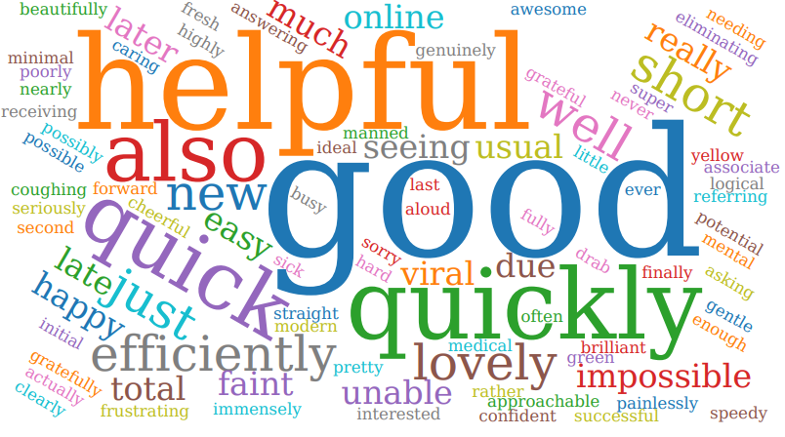

Examples of Comments
- “Whenever I need an appointment, I get one no problem. Seen the nurse practitioner who has helped me get my diabetes under control. All you the staff at the surgery are very helpful”
- “Great receptionist service. Community Midwife was efficient”
- “Very punctual and the doctor was interested and treated my condition seriously.”
- “Appointment changed at short notice due to staff illness so happy wasn't just cancelled. good communication from surgery and see”
- “Actually, arranging the appointment was a nightmare. It's really dispiriting to phone for an appointment and find you are 31st in a queue. But having got it the service within the surgery was excellent, especially as I was late for the appointment because my car broke down.”
- “Almost impossible to get through on the phone. I rang 08:02 the other day & was 27th in a queue also seeing a doctor rather than a practitioner who is
unable to prescribe medication or experience of complex medical cases.”

The Formby Village Surgery Feedback-
At the Surgery we offer alternative services to help reduce the time patients are waiting for appointments with the Village Surgery. The 7-Day Service is a great alternative option that specialise in out of hours weekday appointments as well as weekends. They offer a range of appointments from General Health Concerns to the annual reviews.
We apologise for the inconvenience caused by the staff sickness, and we are glad that you were happy with the arrangement we had to make.

