**Friends and Family Data–May-2025**

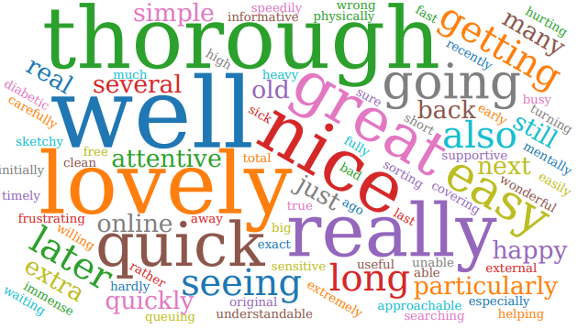

**Summary of Patient Comments**

* **“Sister was lovely, all on time”**
* **“Always treated well”**
* **“Quick service, seen the same day”**
* **“Prompt appointment. Nice nurse”**

|  |  |  |
| --- | --- | --- |
| Total Responses | 149 | |
| Very Good | 125 | 83% |
| Good | 16 | 11% |
| Neither good nor poor | 2 | 1% |
| Poor | 3 | 2% |
| Very Poor | 3 | 2% |
| Don’t know | 1 | 1% |

Examples of Comments

* *“Very pleased to have a consultation this afternoon, felt listened to & received treatment.”*
* *“I saw the nurse, Dawn, who took a blood sample. She was quick, efficient, friendly, and I hardly felt a thing!”*
* *“The nurse we saw was so helpful and gave my husband a very thorough medical. She made several useful suggestions to make life easier as well.”*
* *“Although it is sometimes difficult to make an appointment when you do see a doctor/practitioner the service is excellent - particularly referrals to specialists when necessary “*
* *“Struggled to initially get an appointment, after numerous calls, given advice to submit an online form, which was unsuccessful. Eventually got one 6 weeks later. Arrived at practice no car parking spaces, checked in said dr was 29 mins behind.”*

The Formby Village Surgery Feedback-

We do encourage the use of the online consultation form via our website to bypass the need for a telephone call and a potential wait on the line. The online consultation is the earliest point of contact opening at 7:30 in the morning. If there is any trouble with this in the future, please contact us.