Friends and Family Data–June-2025
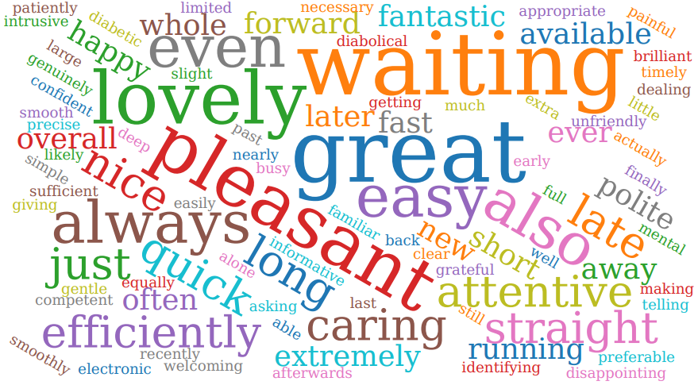
Summary of Patient Comments
- “Staff always patient and helpful”
- “Very simple process, easy to book in and great doctor”
- “Plenty of reminders. Appointment on time”
- “V good attitude from physician associate”
Total Responses | 150
Very Good | 121 | 81%
Good | 20 | 13%
Neither good nor poor | 6 | 4%
Poor | 2 | 1%
Very Poor | 1 | 1%
Don’t know | 0 | 0%
Examples of Comments
- “Efficient care, thorough in their investigation, clear diagnosis. They even texted me with confirmation of appointment, as evidence for work.”
- “Lovely surgery. They genuinely care. Always make same day appointments and give people time and listen during the appointment. Not just one doctor all the doctors. The reception admin team are equally as kind. Very grateful.”
- “Called me back on two occasions as promised and the arranged same day appointment with nurse at Freshfield Practice. The GP assistant was very professional and attentive. She listened to everything I said and explained everything clearly”
- “Nurse was great doctor was great .. only little complaint was I was waiting 30mins as doctor was running late .. but we just need more doctors so I understand. Plus's it would surprise me if they even manage to have their lunch!! Bless them .. the place wasn't overcrowded, so it didn't put me off waiting ... and it's nice to see familiar faces and not new staff all the time. So I think it's very good.”
- “Appointment system is diabolical, often waiting hours on the line only to be told no appointments left when someone finally answers”

The Formby Village Surgery Feedback-
We have introduced a new phone schedule with our staff, that means for the first couple hours of the day, the phones will be attended by most of our staff. We have recorded a huge improvement in the wait times and call back quality.
We do also encourage the use of the online consultation form via our website to bypass the need for a telephone call and a potential wait on the line. The online consultation is the earliest point of contact opening at 7:30 in the morning.

