Friends and Family Data–October-2024
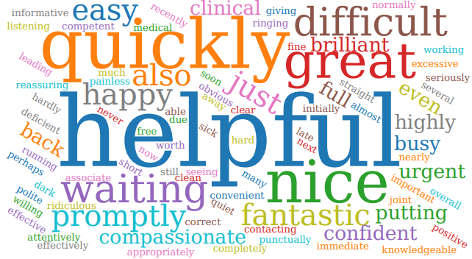
Summary of Patient Comments
- “Prompt service, helpful and friendly”
- “Quick triage and visit”
- “Very nice staff and seen on time”
- “Compassionate and professional”
Total Responses | 151
Very Good | 121 | 80%
Good | 22 | 15%
Neither good nor poor | 2 | 2%
Poor | 3 | 2%
Very Poor | 1 | 1%
Don’t know | 2 | 1%
Examples of Comments
- “Was seen quickly after ringing late morning and appropriately referred to A&E”
- “Practice Nurse so thorough in her procedure and explanations. Excellent communicator and highly empathetic”
- “Good quality and prompt service. Had confidence in the health professional who took the blood sample. Process and timeframe for analysis, results and future actions explained.”
- “The people I spoke to were great but the ability to see a dr or speak to someone quickly is difficult and seems to be getting worse”
- “Arrived for joint 3-way appointment but due to misinformation only 2 parts of the appointment had been made. Interactions with GP and practice nurse were positive. Have to attend another day for third part”
- “Nearly an hour waits”
The Formby Village Surgery Feedback-
At the Surgery we offer alternative services to help reduce the time patients are waiting for appointments with the Village Surgery. The 7-Day Service is a great alternative option that specialise in out of hours weekday appointments as well as weekends. They offer a range of appointments from General Health Concerns to the annual reviews.

