Friends and Family Data–July-2025
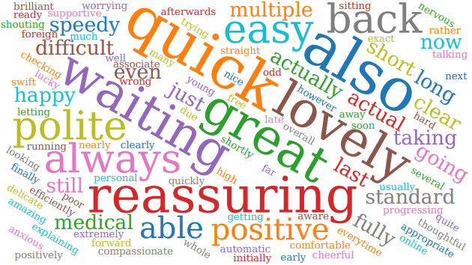
Summary of Patient Comments
- “So helpful and really friendly”
- “The PA was very thorough and efficient”
- “Nurse made me comfortable before bloods taken”
- “Great GP, very friendly”
Total Responses | 150
Very Good | 113 | 76%
Good | 28 | 19%
Neither good nor poor | 6 | 4%
Poor | 0 | 0%
Very Poor | 1 | 1%
Don’t know | 0 | 0%
Examples of Comments
- “I have always found the staff to be pleasant, patient and efficient. I visited the surgery today and the booking in system is so easy and quick to use too.”
- “Easy to book appointment via phone. Appointment offered promptly. Doctor saw us on time, good consultation- clear communication. Thank you.”
- “Within a short time, I received a call back from a very polite professional lady who put me on triage, to which I was then again shortly afterwards called back by a very polite professional young man who gave me an appointment time. You could not ask for more”.
- “Automatic check in. Excellent blood test taken. Poor parking”
- “My personal experiences have been positive except with the phone service”.
- “Took my weeks to get appointment. Wait for doctor was 50 mins. GP Consult was good.”

The Formby Village Surgery Feedback-
We have introduced a new phone schedule with our staff, that means for the busiest hours of the day, the phones will be attended more staff from all departments. We have started to see a huge improvement in the wait times and call back quality.
We do also encourage the use of the online consultation form via our website to bypass the need for a telephone call. The online consultation is the earliest point of contact opening at 7:30 in the morning.

