Friends and Family Data–March-2025
Summary of Patient Comments
- “Polite, efficient and prompt service.”
- “Great Doctor. Friendly knowledgeable staff”
- “Friendly staff, call back feature worked well, seen quickly.”
Total Responses | 150
Very Good | 122 | 81%
Good | 18 | 12%
Neither good nor poor | 1 | 1%
Poor | 4 | 3%
Very Poor | 5 | 3%
Don’t know | 0 | 0%

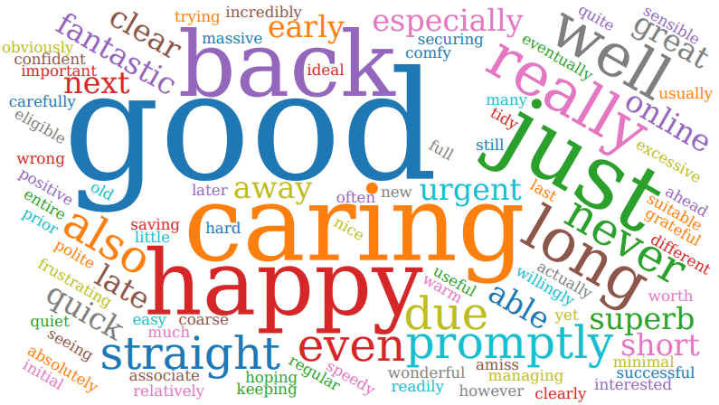
Examples of Comments
- “Because I was able to get an appointment the same day and was treated with courtesy, respect and thoughtfulness”
- “Other than the wait time on the phone to obtain an appointment, the administrative staff and medical staff are excellent. They are very attentive and effective within their respective roles”
- “I had an 8.30 appointment which was the first appointment of the day, due to work commitments I needed an early appointment. I was seen at 8.50. I can understand through the day appointment can go over. However, a 20-minute wait for the first appointment I think was excessive”
- “Waited for 30 minutes and had to walk out to take my daughter to her Hobbie. Always a wait”
- “Impossible to get an appointment when it's convenient for me. Ringing on the day as requested doesn't guarantee you appointment but you also can't book in advance. Full time workers are not considered”

The Formby Village Surgery Feedback-
At the Surgery we offer alternative services to help meet the time criteria of patients. The 7-Day Service is a great alternative option that specialise in out of hours weekday appointments as well as weekends. They offer a range of appointments from General Health Concerns to the annual reviews.

